Day 6 Activity2 Worksheet Your name: ________

Task A
Circle the characters with component “巾 “.

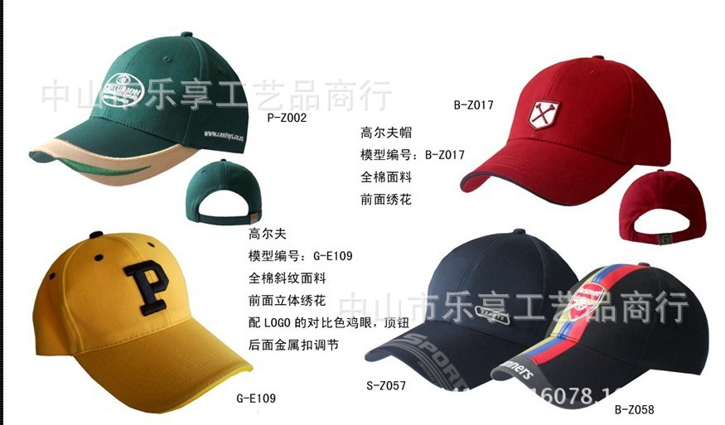

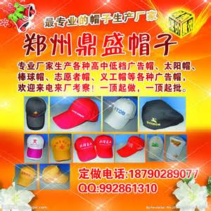

Task B “巾” 在哪儿？
Where is “巾” located in each character?

1.帽mào 2.币bì 3.帛bó 4.希 xī 5.布bù
6.带dài 7.常cháng 8.佩pèi 9.幅fú 10.帅shuài
11.狮 shī

Identify the position of “巾” in each character and write the number of the character.

On the right：

On the left：

At the bottom：

In between：

Inside:右边左

